**TOPIC 1) BASICS**

**Checking the Status:**

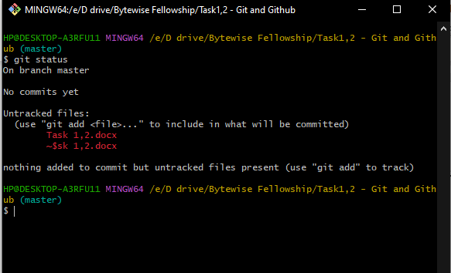

**Getting Ready to Commit:**

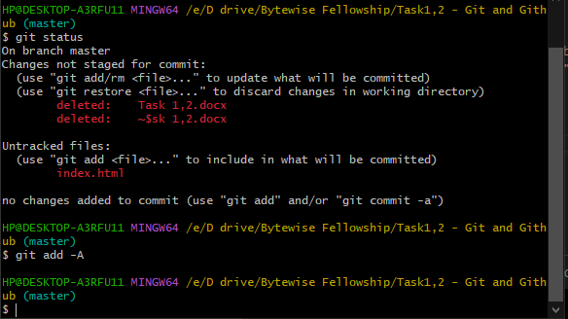

**Committing Your Work**

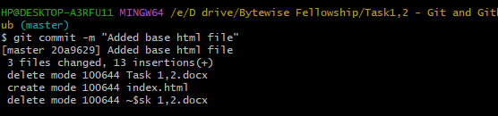

**Inspecting the Commit History**

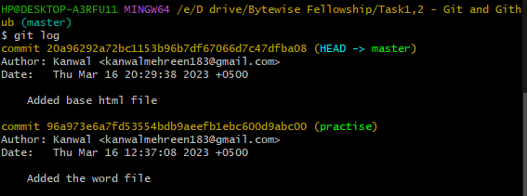

**TOPIC 2) BRANCHING & MERGING**

**Working with Branches**

**Saving Changes Temporarily**

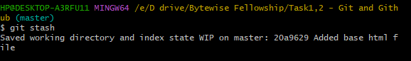

**Checking out to newly created branch**

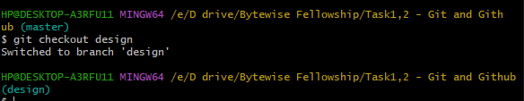

**Making changes and commit**

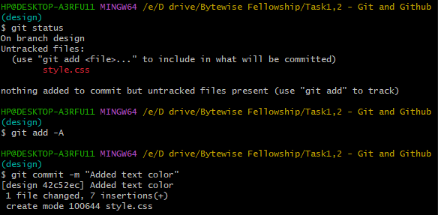

**Switching to Main Branch**

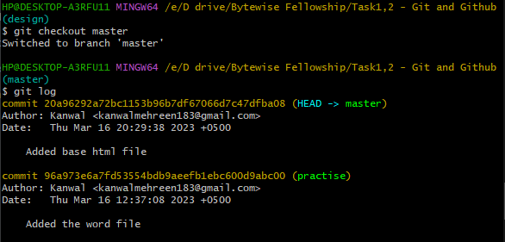

**Merging with Main Branch**

